Internet programming
Lab Experiment 1
Aim
To develop a Library Management System that helps students search and borrow books, access study materials, and allows librarians to manage books, users, returns, and fines efficiently.
Algorithm
- Start the system.
- Login/Register as Admin or User.
- Users search books, view details, borrowing history, fines, and study materials.
- Admin adds, updates, or deletes books and materials.
- Admin issues and receives returned books.
- Calculate fines for overdue books.
- Update all records.
- End the system
Program:
<!DOCTYPE html>
<html>
<head>
<title>Library Management System</title>
<style>
body {
font-family: Arial, sans-serif;
margin: 0;
background: #f4f7f9;
}

header {
background: #174873;
color: white;
padding: 20px;
text-align: center;
}

nav a {
color: white;
margin: 12px;
text-decoration: none;
}

section {
padding: 25px;
margin: 15px;
background: white;
border-radius: 8px;
}

h2 {
color: #174873;
}

table {
width: 100%;
border-collapse: collapse;
}

th, td {
border: 1px solid #ccc;
padding: 10px;
text-align: left;
}

th {
background: #dceaf5;
}

input, textarea {
display: block;
width: 95%;
padding: 10px;
margin: 10px 0;
}

button, .button {
background: #174873;
color: white;
padding: 10px 16px;
border: none;
cursor: pointer;
text-decoration: none;
border-radius: 4px;
}

.cards {
display: flex;
flex-wrap: wrap;
gap: 15px;
}

.card {
background: #e0edf7;
padding: 15px;
flex: 1;
min-width: 120px;
text-align: center;
}

footer {
background: #174873;
color: white;
text-align: center;
padding: 12px;
}

.available {
color: green;
}

.issued {
color: red;
}
</style>
</head>
<body>

<header>
<h1>College Library Management System</h1>
<nav>
<a href="#home">Home</a>
<a href="#books">Books</a>
<a href="#login">Login</a>
<a href="#admin">Admin</a>
<a href="#contact">Contact</a>
</nav>
</header>

<section id="home">
<h2>Welcome to College Library</h2>
<p>Find books, manage borrowing history,
and access library materials.</p>
<a href="#books" class="button">View Books</a>
</section>

<section id="books">
<h2>Book List</h2>
<input type="text" id="search"
placeholder="Search Book"
onkeyup="searchBooks()">

<table id="bookTable">
<tr>
<th>Book ID</th>
<th>Book Name</th>
<th>Author</th>
<th>Year</th>
<th>Status</th>
</tr>
<tr>
<td>101</td>
<td>Computer Networks</td>
<td>Tanenbaum</td>
<td>2022</td>
<td class="available">Available</td>
</tr>
<tr>
<td>102</td>
<td>Database Management</td>
<td>Ramakrishnan</td>
<td>2021</td>
<td class="available">Available</td>
</tr>
<tr>
<td>103</td>
<td>Operating System</td>
<td>Silberschatz</td>
<td>2023</td>
<td class="issued">Issued</td>
</tr>
<tr>
<td>104</td>
<td>Web Technology</td>
<td>Robert Nixon</td>
<td>2024</td>
<td class="available">Available</td>
</tr>
</table>
</section>

<section id="login">
<h2>Student Login</h2>
<form onsubmit="loginStudent(event)">
<label>Email</label>
<input type="email" required
placeholder="Enter Email">

<label>Password</label>
<input type="password" required
placeholder="Enter Password">

<button type="submit">Login</button>
</form>
<p id="loginMessage"></p>
<p>New Student? <a href="#contact">Register</a></p>
</section>

<section id="admin">
<h2>Admin Dashboard</h2>
<div class="cards">
<div class="card">
<h3>Total Books</h3>
<p>500</p>
</div>
<div class="card">
<h3>Issued Books</h3>
<p>120</p>
</div>
<div class="card">
<h3>Students</h3>
<p>300</p>
</div>
<div class="card">
<h3>Total Fine</h3>
<p>₹2500</p>
</div>
</div>

<h3>Library Operations</h3>
<button onclick="alert('Add Book selected')">Add Book</button>
<button onclick="alert('Update Book selected')">Update Book</button>
<button onclick="alert('Delete Book selected')">Delete Book</button>
<button onclick="alert('Issue Book selected')">Issue Book</button>
<button onclick="alert('Return Book selected')">Return Book</button>
<button onclick="alert('Fine management selected')">Make Fine</button>
</section>

<section>
<h2>Study Materials</h2>
<table>
<tr>
<th>Year</th>
<th>Semester</th>
<th>Subject</th>
<th>Material</th>
</tr>
<tr>
<td>1st Year</td>
<td>Semester 1</td>
<td>Programming</td>
<td>Study notes</td>
</tr>
<tr>
<td>2nd Year</td>
<td>Semester 3</td>
<td>Database</td>
<td>Study notes</td>
</tr>
<tr>
<td>3rd Year</td>
<td>Semester 5</td>
<td>Web Technology</td>
<td>Study notes</td>
</tr>
</table>
</section>

<section id="contact">
<h2>Contact Us</h2>
<form onsubmit="sendMessage(event)">
<label>Name</label>
<input type="text" required
placeholder="Enter Name">

<label>Email</label>
<input type="email" required
placeholder="Enter Email">

<label>Message</label>
<textarea required
placeholder="Enter Message"></textarea>

<button type="submit">Send</button>
</form>
<p id="contactMessage"></p>
</section>

<footer>
<p>© 2026 College Library Management System</p>
</footer>

<script>
function searchBooks() {
let input = document.getElementById("search")
.value.toLowerCase();
let rows = document.querySelectorAll(
"#bookTable tr"
);

for (let i = 1; i < rows.length; i++) {
rows[i].style.display =
rows[i].innerText.toLowerCase()
.includes(input) ? "" : "none";
}
}

function loginStudent(event) {
event.preventDefault();
document.getElementById("loginMessage")
.innerText =
"Login form submitted successfully (demo).";
}

function sendMessage(event) {
event.preventDefault();
document.getElementById("contactMessage")
.innerText =
"Your message has been submitted (demo).";
event.target.reset();
}
</script>

</body>
</html>
Output: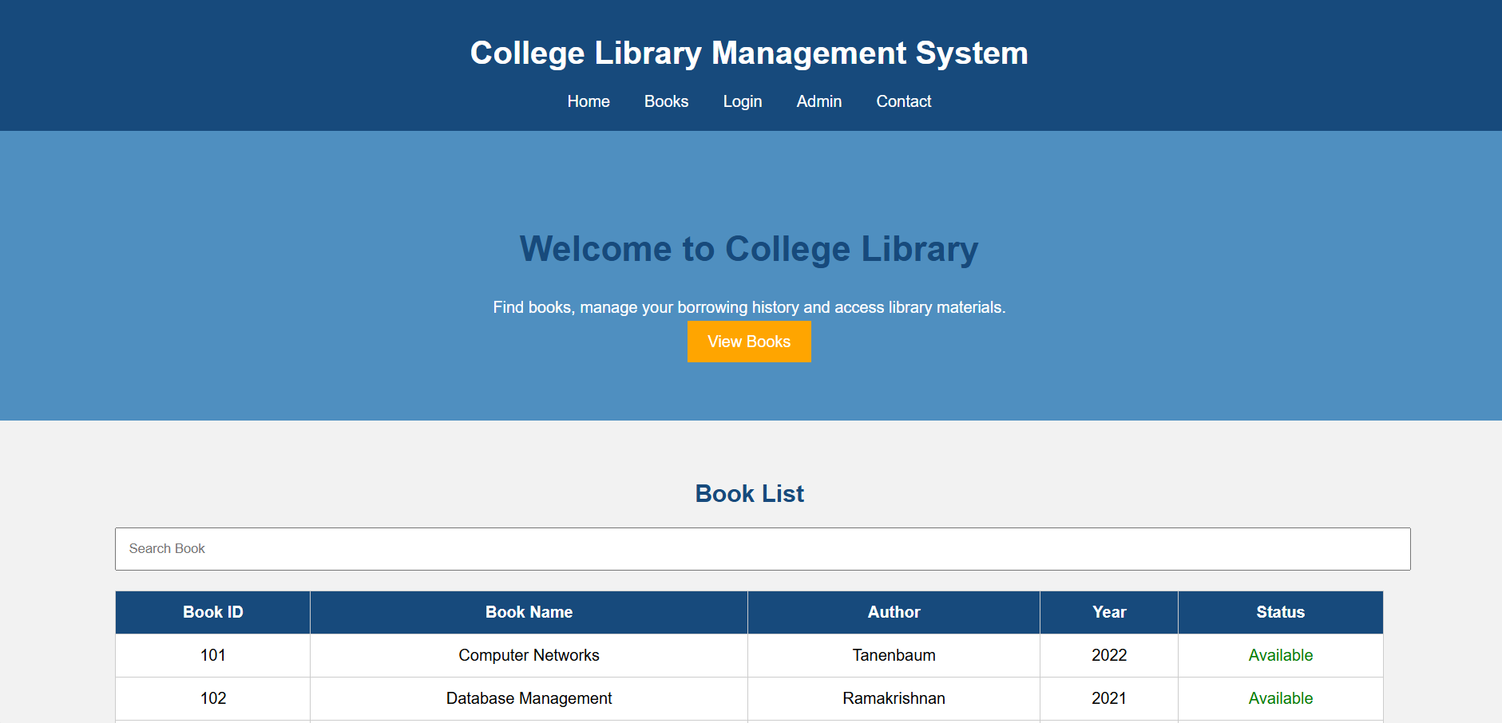
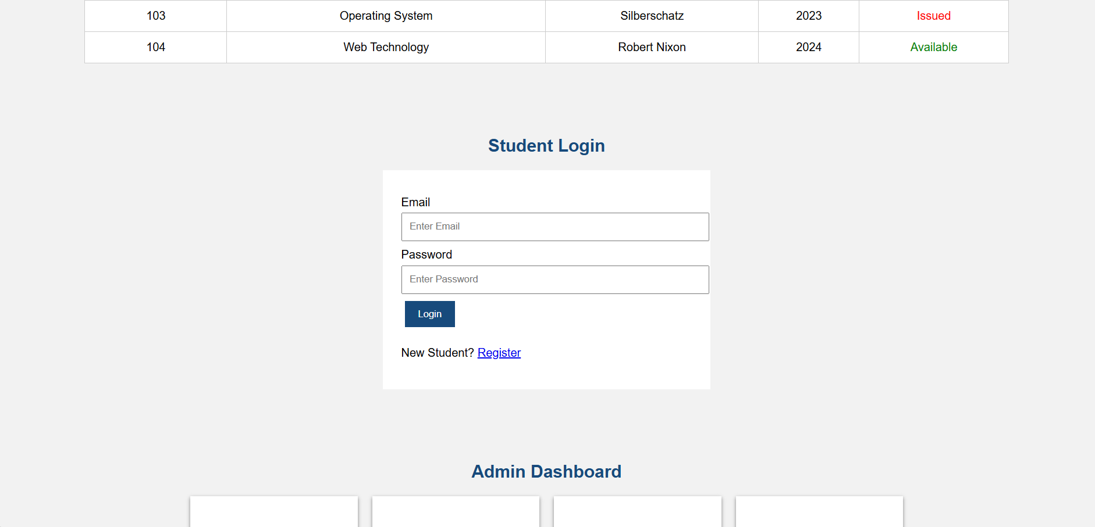
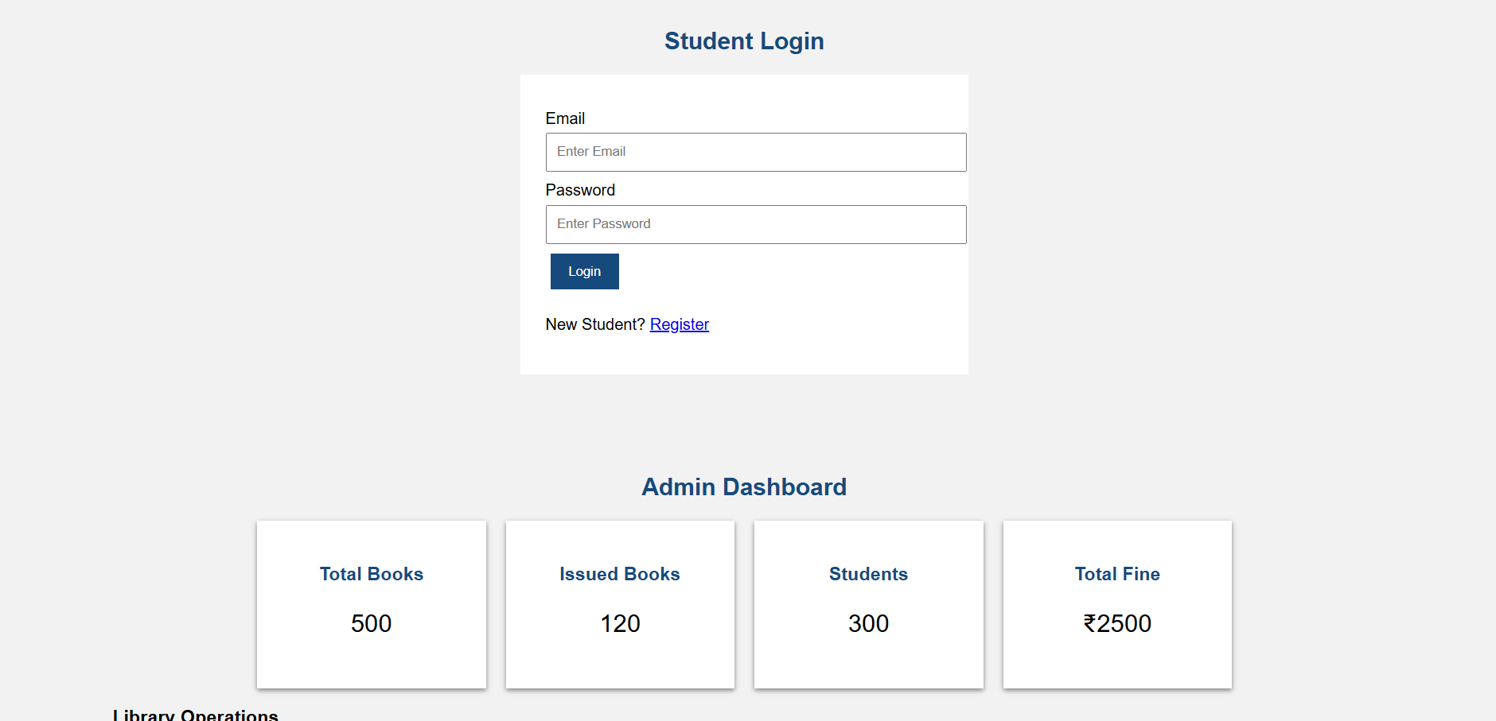
Result:
The system successfully manages the books ,users, borrowing, returns,fines and study materials,reducing manual work and making library operations faster and easier.

